LEO BAECK COLLEGE
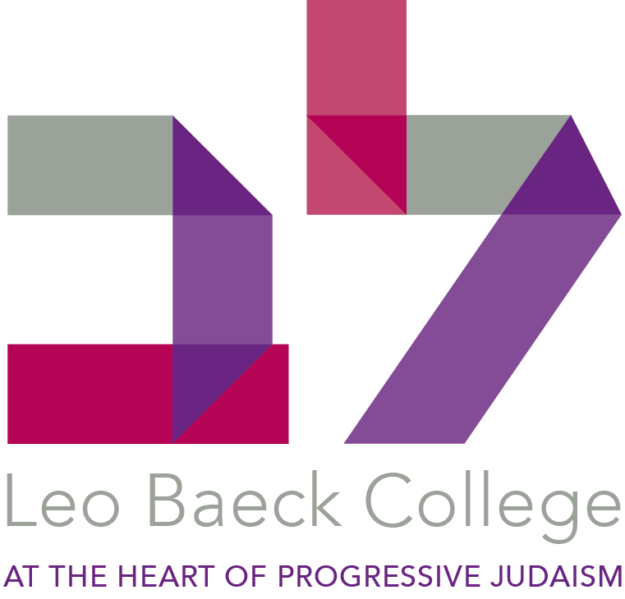

LIBRARIAN

A great opportunity has arisen for the post of Librarian at Leo Baeck College to start at the beginning of September 2018. This position is the perfect chance for the right person to work in our wonderful library and to be part of the College family.

The ideal candidate will be able to demonstrate the following:

- A qualification in library sciences or experience of working in an academic library.
- Basic knowledge of Jewish Studies as an academic discipline
- English and Hebrew language skills
- Excellent organisational skills
- Excellent interpersonal skills
- Good IT skills overall and also particularly in relation to library management
- Experience of working in a team but also ability to work on own initiative

Salary: £30,000 to £35,000 dependent on experience and qualifications
Post: Full-time.
Possible teaching opportunities for suitably qualified candidates.
Job shares will also be considered.
Statutory and Jewish holidays with early closing on Friday.

For a full job description and application form see the work for us section of the LBC website (www.lbc.ac.uk) or contact Rhona Lesner on + 44 (0)20 8349 5621, email rhona.lesner@lbc.ac.uk.

Completed applications, including a full CV and names of referees, should be sent to: Rhona Lesner, Leo Baeck College, Sternberg Centre for Judaism, 80 East End Road, London N3 2SY

The Search Committee will begin to review applications after the closing date of Thursday 5th July. Interviews will take place on 18th July 2018.

Leo Baeck College offers training for rabbis and educators for the Progressive Jewish world in the UK and Europe. Its degree courses are validated by Middlesex University. The College Library has holdings in excess of 60,000 titles, including a collection of rare books and archival materials.

